User Orientation Document of E-commerce
Sales Dashboard

N0 | Description | Page no
1 | Introduction & Purpose | 3
2 | Structure & Organization | 3
3 | Dashboard Features & components | 5
4 | Step-by-step Navigation | 6
5 | Interactivity & User Functionalities | 6
6 | FAQ Troubleshooting | 7

Introduction
This guide is here to help users get comfortable with the e-commerce Power BI dashboard. It's designed to make it easy to explore and understand key business data. With this dashboard, users can track sales performance, monitor profits, analyze different customer segments, and spot trends in product sales. The real-time visuals and insights make it easier to make smart, data-driven decisions.

Purpose
The Purpose of this dashboard is to help users easily understand and compare e-commerce sales, profit, and discount trends over time, across products, categories, and customer segments.

Structure & Organization
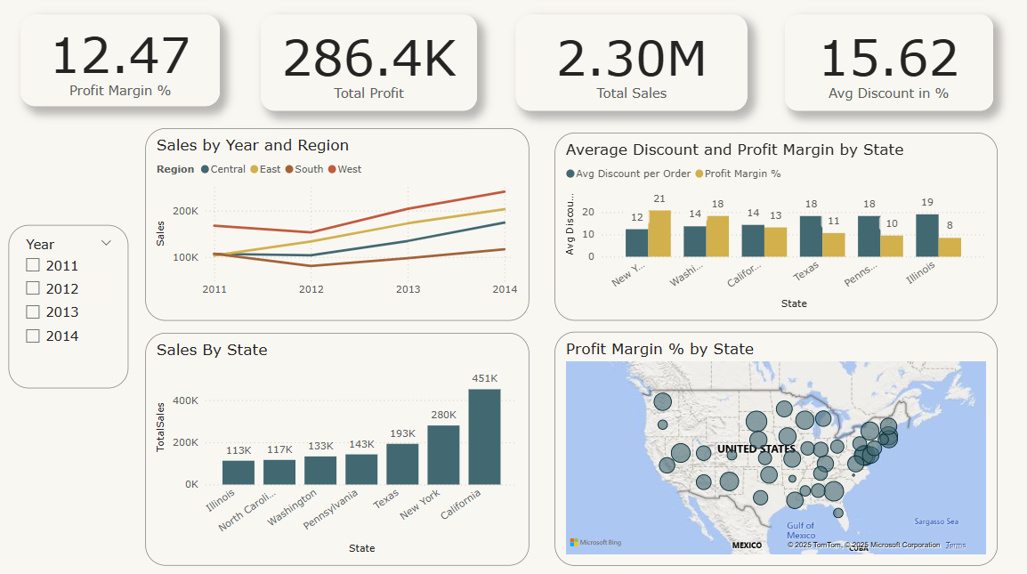

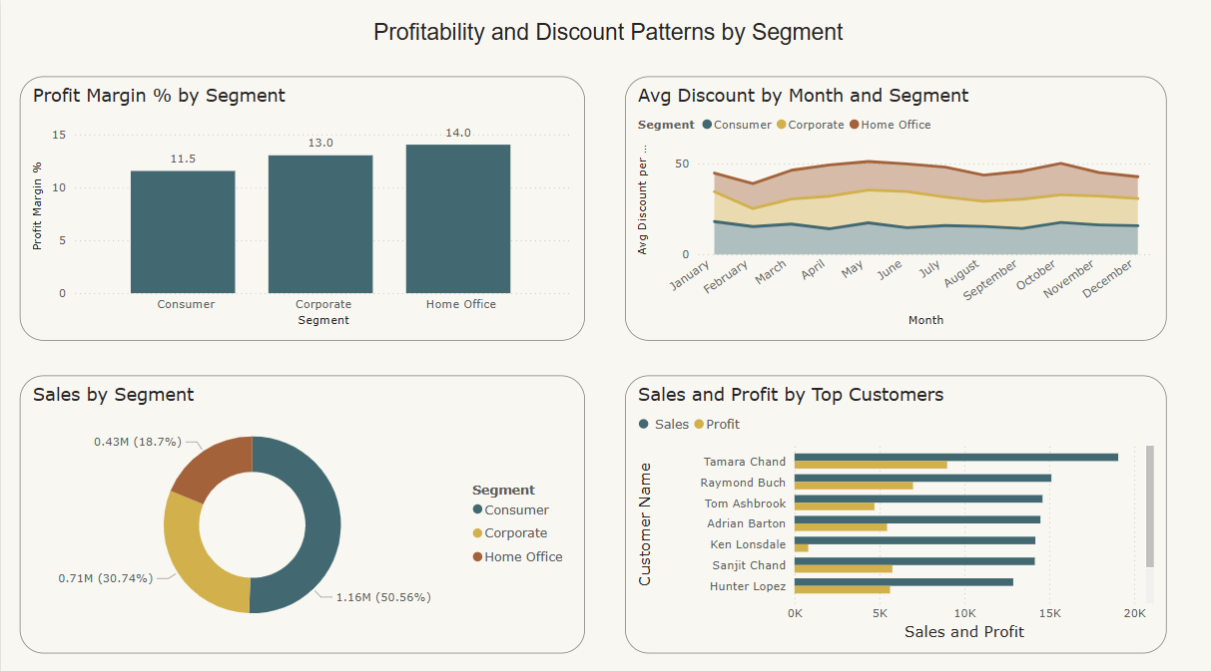

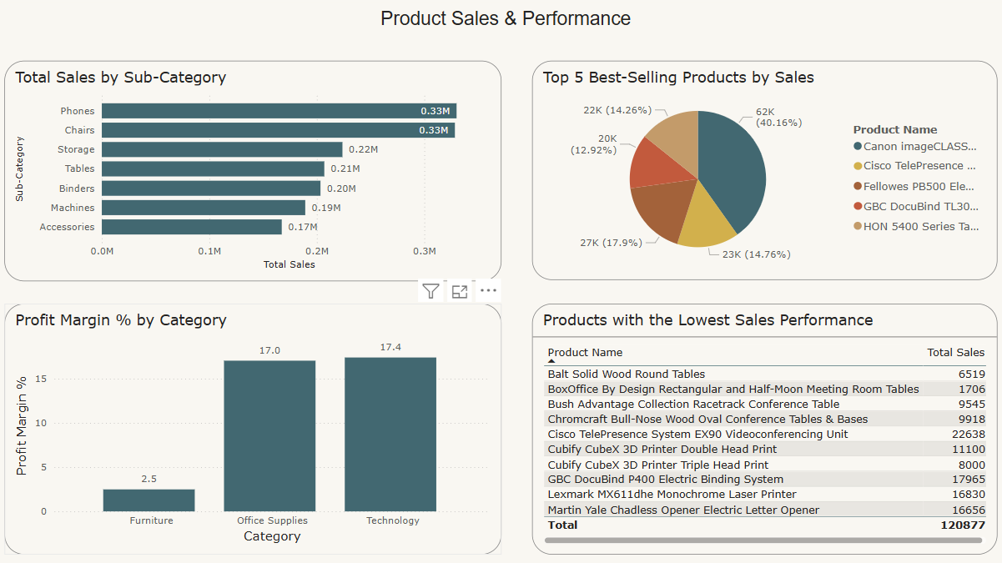
Dashboard Overview
The dashboard is designed to give a clear summary of e-commerce performance through a mix of high-level KPIs and detailed visuals:
- Top Section: Shows key metrics like total sales, total profit, profit margin, and average discount.
- Middle Section: Visualizes trends over time, including sales by region, state, and segment.
- Bottom Section: Focuses on deeper insights such as sales by product category, top-performing products, and most valuable customers.
This layout helps users quickly find both overall performance and detailed breakdowns to support data-driven decisions.

Dashboard Features & Components

KPIs (Key Performance Indicators):
Located at the top, these show a quick summary of key metrics including Total Sales, Total Profit, Profit Margin %, and Average Discount %, offering an immediate performance overview.
Line Graphs:
Depict yearly, monthly, time series sales trends across regions, allowing users to analyze growth and seasonal fluctuations over time.
Bar Charts:
Display insights such as:
- Total Sales by Product Sub-Category (e.g., Chairs, Phones)
- Profit Margin % by Segment and Category
- Sales and Profit by Top Customers
- Sales by U.S. State
Pie/Donut Charts:
Used to illustrate:
- Sales Distribution by Segment (Consumer, Corporate, Home Office)
- Top 5 Products by Sales Volume and Percentage Contribution
Maps:
Geographical distribution of profit margin and total sales by U.S. states using bubble maps for easy visual comparison.
line and clustered column chart:
Blend bar and line visuals to compare Average Discount and Profit Margin % by State.
Customer-Level Data Table:
Lists top customers with their corresponding sales and profit values, helping to identify high-value individuals.

Step-by-step Navigation

Opening the Dashboard
To access the dashboard, log in to the designated platform (e.g., Power BI, internal analytics portal) and select the e-commerce sales dashboard from the list of available dashboards.
Exploring Main Sections
KPI Section: At the top, you will find the key metrics such as Total Sales, Total Profit, and Profit Margin and Avg Discount.
Sales Trends (Line Graph): Located in the middle left, this chart shows how sales have progressed over time, allowing you to observe peaks and dips.
Product & Category Breakdown: This section includes both a pie chart of top product sales and a bar chart of sales by category (e.g., Technology, Furniture).
Segment & State Breakdown: The donut chart shows total sales by segment (Consumer, Corporate, Home Office), while the map highlights total orders by state.
Utilizing Filters: On the left sidebar, you will find drop-down filters to customize the view based on Total Sales by Year, Month, Days. You can also filter data by product category, customer segment, or other specific variables depending on the available filters.

Interactivity & User Functionalities

- Drilling Down:
Click on a line chart in the sales chart to see more detailed data, like sales by month or Year.
- Hover Actions:
Hover over chart elements to see extra details, such as exact sales figures and their percentage of total sales.

- Export/Download Options:
To export data or download charts, click the three dots in the top-right corner of a visual. Choose to export the data or download the visual as PNG, PDF, or Excel.
- Adjusting Timeframes:
Use the drilldown to change the time frame for data visualization. This lets you focus on specific periods, like the last quarter or year-to-date performance.

FAQ & Troubleshooting

Question: How do I view customer-level sales and profit data?
Answer: Refer to the "Sales and Profit by Top Customers" bar chart, which shows detailed data on key customers. Hovering over the bars will also display sales and profit values.
Question: How often is the data updated?
Answer: Data is typically refreshed on a scheduled basis (e.g., daily, weekly). Check the “Last Refreshed” timestamp on the dashboard. For immediate updates, contact the data administrator.
Question: Why can't I see data for a specific year?
Answer: Check the "Year" slicer to ensure the correct year(s) are selected. If a year is unchecked, its data will be excluded from all visualizations.
Question: How often is the data updated?
Answer: Data is typically refreshed on a scheduled basis (e.g., daily, weekly). Check the “Last Refreshed” timestamp on the dashboard. For immediate updates, contact the data administrator

